www.jhp.com.au
sales@jhp.com.au
(03) 98770888

VF UTE LED TAIL LIGHT RESISTOR FITTING INSTUCTIONS
- Remove 6 push pin clips to take side panel off
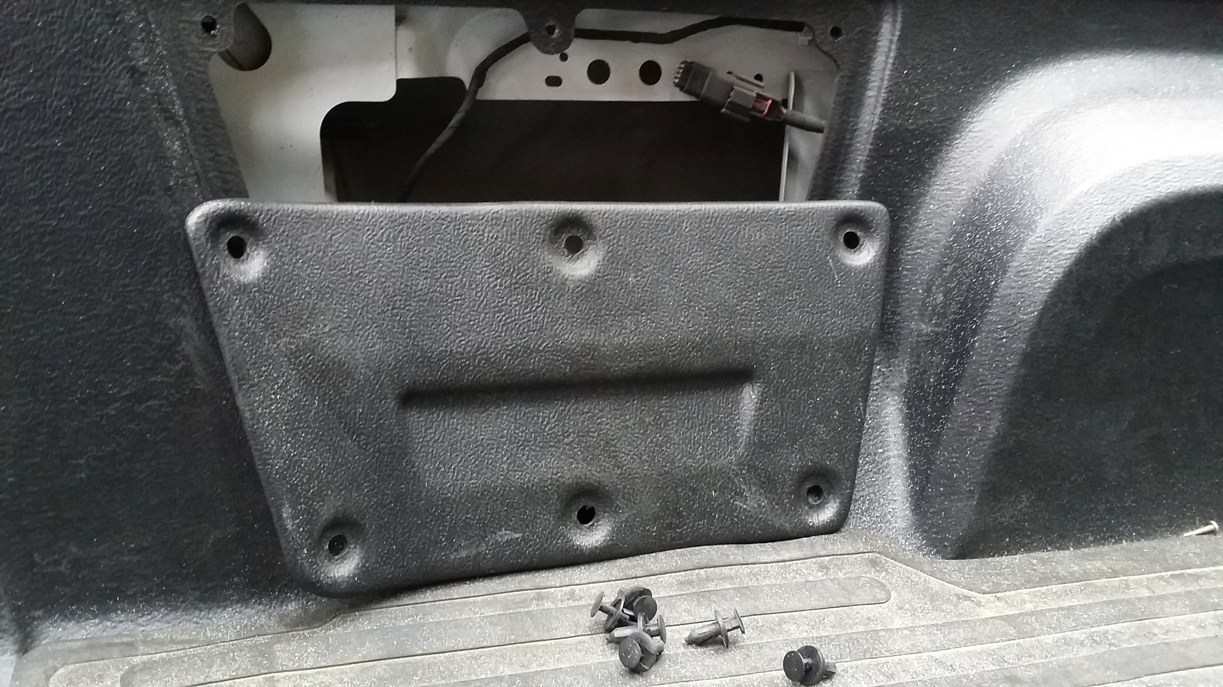

- Undo 3x plastic nuts with 13mm socket to take tail light off, slide tail light out and unplug the tail light

- Peel double sided tape and stick resistor to flat surface as shown

- Take any white wire end from resistor and join it to the grey wire with yellow stripe. Join another white wire end to the black wire (just on top the grey wire with yellow str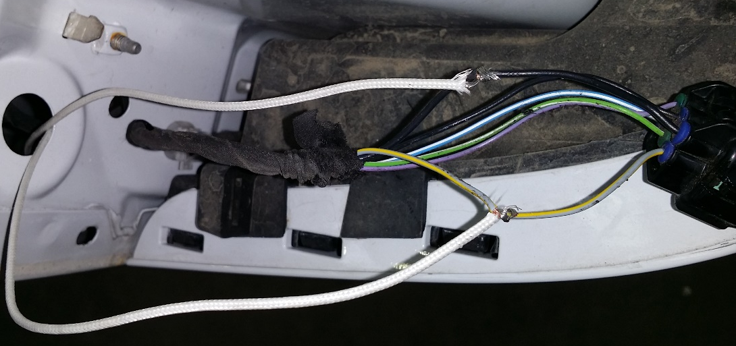

- Solder two connection and cover with electrical tape

Note: plug tail light loom in and test for operation insuring no warning light on the dash.
For any query please contact us.
Website: www.jhp.com.au
Email: sales@jhp.com.au
Ph: 03 98770888

